CPI adjustment

To convert all dollar values into December 2025 dollars, I downloaded CPI data for December from 2004 to 2025.Then I calculated the ratio between each year’s CPI and dec 2025 CPI. For conversion, I later multiply the nominal dollar amount by the corresponding ratio for each year from 2004-2024.

In terms of the data used, the CPIAUCNS.csv file contained the CPI values for each year and was mainly used to calculate all of the conversion ratios. Other than that, EADA and IPEDS contained all of the nominal dollar values from 2004 to 2024 that were necessary for calculating the data used in later graph generation. They were also part of the CPI adjustment process, because once I had the ratio, I still needed to apply it to the nominal dollar amounts in order to complete the full conversion.

$$CPI adjustment formula=Nominal amount in year X*(\frac{CPI in year 2025}{CPI in year X})$$

In terms of where I acquired all the files used: EADA data were downloaded from the U.S. Department of Education’s Equity in Athletics Disclosure Act (EADA) survey data website. IPEDS finance and enrollment data were downloaded from the Integrated Postsecondary Education Data System (IPEDS) Data Explorer / Use the Data portal. CPI data were downloaded as the CPIAUCNS series from FRED, which republishes BLS Consumer Price Index data.

CAGR description

For the CAGR formula, It is used to summarize the long-run growth rate of tuition. In the public brief, I refer to tuition having increased on average by roughly 1.7 percent per year over the past several decades, which is bigger than the 0.7-1 percent share of athletic, meaning losing the entire athletic program and all of its benefits, our tuition will likely be back to the same place and even higher in shortly one or two years.

It is worth noting that this does not imply that tuition is mechanically set by a fixed compound rule each year; rather, CAGR provides an equivalent constant annual growth rate over the past 21 years.

The formula I used to calculate the average tuition growth rate is CAGR, and it is as follows:

$$CAGR={\left(\frac{EndingValue}{BeginningValue}\right)}^{\frac{1}{21}}-1$$
$$CAGR={\left(\frac{69030}{48105}\right)}^{\frac{1}{21}}-1=0.01734=0.017$$

For the athletic spending per student calculation, I use total institutional enrollment rather than undergraduate-only enrollment. This includes both undergraduate and graduate students, both part-time and full-time. Although it likely understates the per-student athletics burden relative to an undergraduate-only denominator, the tuition is contributed by all the people above and a per student spending on the count of all these tuition contributors would make the data more accurate.
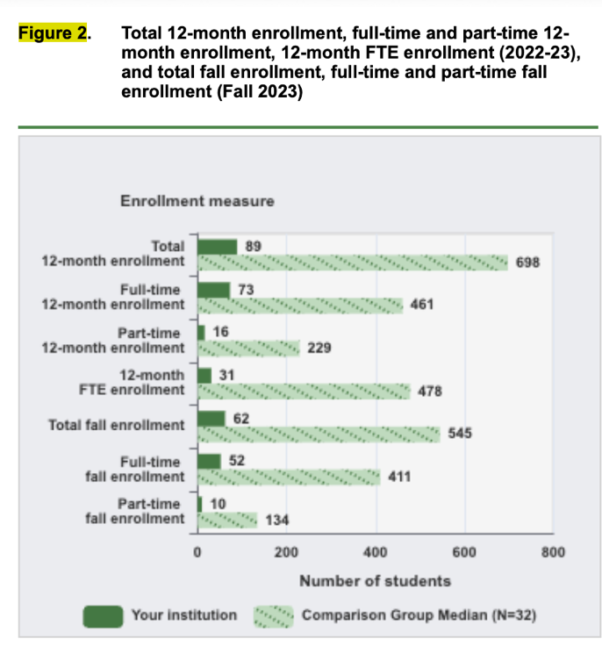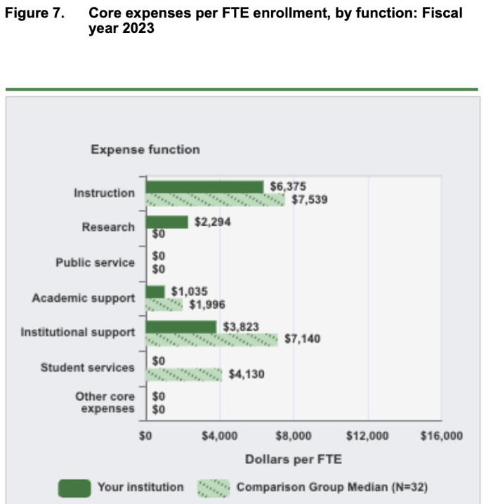
IPEDS’ Data Feedback Report treats FTE enrollment as the relevant denominator for spending intensity. In Figure 2, IPEDS separately reports total headcount and 12-month FTE enrollment, and in Figure 7 it reports core expenses on a per-FTE basis, indicating that FTE is the most reasonable weighted-enrollment measure for per student spending comparison.
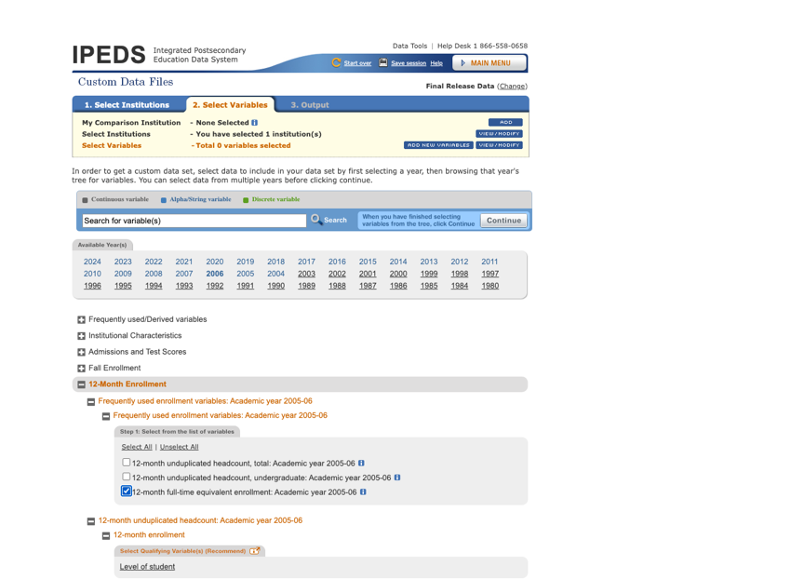

Weighted enrollment is measured using IPEDS 12-month full-time equivalent (FTE) enrollment. Rather than assigning my own arbitrary weight to part-time students, I use the official IPEDS FTE measure directly. Athletics spending per weighted student is then calculated as real athletics expenses divided by IPEDS 12-month FTE enrollment.
The use of this weighted enrollment is mainly involved in the calculation of athletic spending per student, where the formula is as follows:
$$Athletic spending per student=\frac{AthleticExpenses}{12_month_FTE_enrollment}$$
How I accessed the IPEDS data
I accessed all IPEDS data through the IPEDS Data Center. For the enrollment data, after entering the website, I clicked Custom Data Files, and then began inputting the school name, the type of data needed, and the variables needed. More specifically, I clicked on each year from 2004 to 2023, opened 12-Month Enrollment, and selected 12-month full-time equivalent enrollment as the variable. After that, all of the files appeared on the page for download, and I had to click download 21 separate times, since there was no option to download them all in a single file.
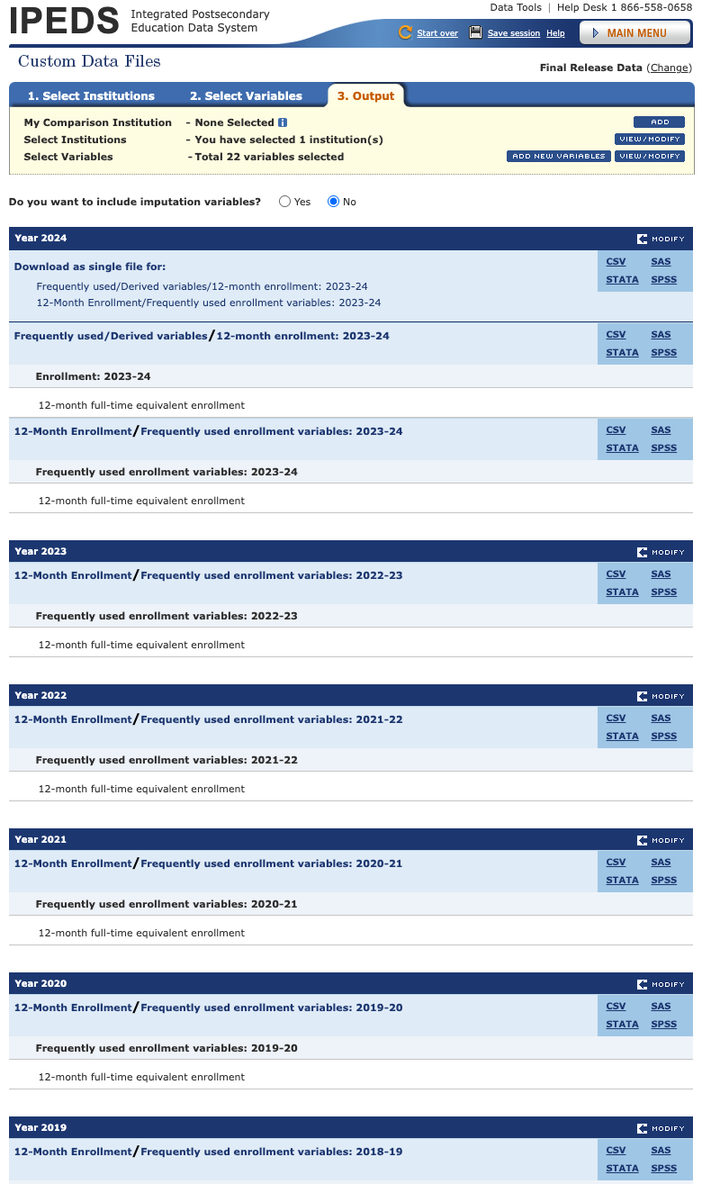
However, for the finance data, I could not find it by choosing the University of Rochester directly, so I entered through Complete Data Files, downloaded the data for all schools, and then retrieved the University of Rochester data through its Unit ID.

Measurement Questions and Limitations
For the tuition growth rate, it is calculated using CAGR, meaning that it is a hypothetical measure of what constant or average annual growth rate would lead from the 2004 tuition level to the tuition level today. That said, although I argue that the sports spending share is less than the tuition growth percentage, this might not literally hold in every single future year. The University of Rochester might increase tuition by much more or much less than 1.7 percent in the next year, the year after that, and so on. In fact, when looking at the tuition trend after adjusting all values for CPI, we can see that tuition does not simply go up in a straight line. It actually went down after 2020 and then went back up afterward.
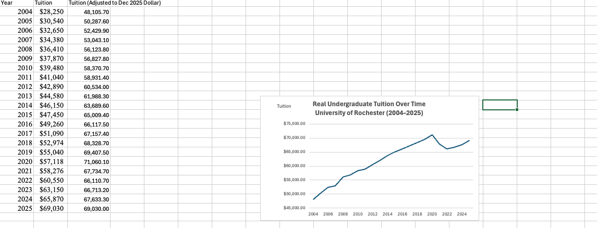

In addition to that, when calculating spending per student, the timing of the IPEDS finance data and the IPEDS enrollment data is not actually aligned. One follows the fiscal year, while the other follows the academic year, meaning the amount of money divided by the FTE headcount could potentially be somewhat more or less than it should be. Lastly, as I mentioned previously, I used FTE as the enrollment headcount, while in reality it is mainly full-time undergraduate students who care about or participate in school sports. Therefore, the final per-student athletics spending might look smaller than it actually is for undergraduate students. Yet, according to the IPEDS DFR, and due to the lack of a clear formula for weighting on my own, FTE seems like the most reasonable approach to use when calculating per-student athletics spending.

